React JS

Table of Contents
Chapter 1: React Overview 3
What is React JS? 3
Why was React Needed ? (The Backstory) 4
Reacts Solution: Component-Based Architecture 5
Real-World Example: YouTube (SPA Concept) 6
JavaScript Prerequisites Before Learning React 7
Creating an Element – Plain JavaScript Way (Before React) 8
Library vs Framework – Key Difference 9
Analogy Given: 9
Chapter 2: Import & Export 10
Why Import / Export is Needed 10
Prerequisite: Setting File Type to “module” 11
Two types of Export 12
Default Export 13
Example with array: 13
Named Export 14
Combining Default + Named Export (same file) 15
Import from Multiple Files 16
Key Takeaways 17
Chapter 3: Real DOM vs Virtual DOM 18
What is Real DOM? 18
The Problem with Real DOM 19
What is Virtual DOM ? 20
Benefits of Virtual DOM 21
Introduction to JSX 22
Calling Function in JSX 24
Chapter 4 – Setting Up React with Vite 25
What is Vite (Bundler) ? 25
Vite vs Create React App (CRA) 26
Creating a React Project with Vite – Step–by–Step 27

Chapter 1: React Overview

What is React JS?
- React JS is basically a JavaScript Library used to make UI (User Interfaces) – essentially, it helps build the frontend.
- Even though HTML, CSS, JS alone can build a frontend, React helps build complex frontends more efficiently.
- Created by: Meta (Formerly Facebook).
- Created in: 2013.
- Founding Developer: Jordan Walke (a Facebook developer).
- It is currently one of the most in-demand skills, even in the age of AI, and learning it well opens up many job opportunities.

Why was React Needed ? (The Backstory)
- Around 2010–2011, as Facebook's user base grew, a major problem emerged with plain HTML/CSS/JS-based websites:
  - The website behaved like a static site — any small update (e.g., a new message notification, a like, a friend request) required reloading the entire page.
  - Example: If someone messages you, the "messages count" badge won't update unless you reload the whole page.
  - Example: If someone likes your post or sends a friend request, the notification/count won't reflect in real time.
- This caused a poor user experience since everything had to reload just to update one small piece of UI.

Reacts Solution: Component-Based Architecture
- React introduced component-based architecture: the entire website is broken into smaller, independent components (chunks/parts).
- Each component can update independently without reloading the rest of the page.
- Example: On a website like sharys.com, if a notification count updates, only that specific component re-renders — not the whole page.
- This results in a much smoother, "buttery smooth" user experience with no unnecessary re-renders.

Real-World Example: YouTube (SPA Concept)
- Though YouTube itself isn't built in React, it's used as an example of a Single Page Application (SPA) — the kind of app React enables.
- When you click on different videos on YouTube:
  - The video player and details section update.
  - The URL changes.
  - But elements like the search bar text stay unchanged/don't reload.
- This selective updating (only relevant parts change) is the core benefit of React — avoiding unnecessary re-renders.

JavaScript Prerequisites Before Learning React
Before diving into React, you should be comfortable with these JS essentials:
- Basics: Variables, Loops, Conditionals (if-else), Data types.
- Functions: Regular functions, Arrow functions, Return statements.
- Arrays: Array methods — map, filter, reduce, forEach.
- Objects: Objects, Object literals, how to use them.
- ES6 Features: let/const, arrow functions, destructuring.
- Asynchronous JS: Promises, Fetch API, Async/Await.

Creating an Element – Plain JavaScript Way (Before React)
Demonstrated using index.html + script.js
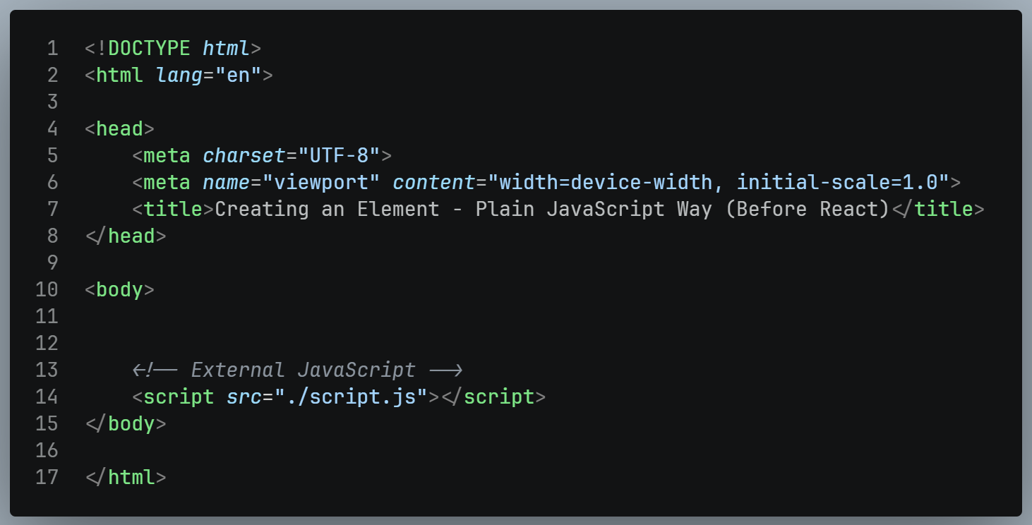
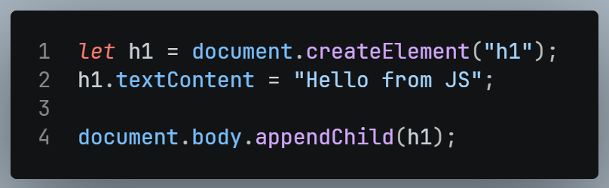
- This is the basic/manual DOM manipulation approach using plain JavaScript — creates an element, sets its content, and appends it to the page.

Library vs Framework – Key Difference
 | Library | Framework
Definition | Used to implement one particular feature | Provides an all-in-one, inbuilt solution.
Customization | High – pick and combine only what we need. | Lower – comes with a fixed structure.
Examples | GSAP (animations), Lenis (Smooth scrolling), React JS (UI). | Next.js, Angular, Remix

Analogy Given:
- Framework = Buying a ready-made flat/apartment — convenient, but limited customization (can't easily expand a room).
- Library = Buying a plot of land and building your own house — more effort, but full customization (e.g., build your bathroom however you like).
- Since React is a library, it focuses specifically on building UI, and developers can pair it with other libraries (like GSAP or Lenis) for other features — giving more flexibility than an all-in-one framework.

Chapter 2: Import & Export

Why Import / Export is Needed
- Working with React (or any modular JS app) requires splitting code across multiple files.
- Problem: If a variable is declared in one file (e.g., app.js), it cannot be directly used in another file (e.g., script.js) — you'll get an error like A is not defined.
- Example:
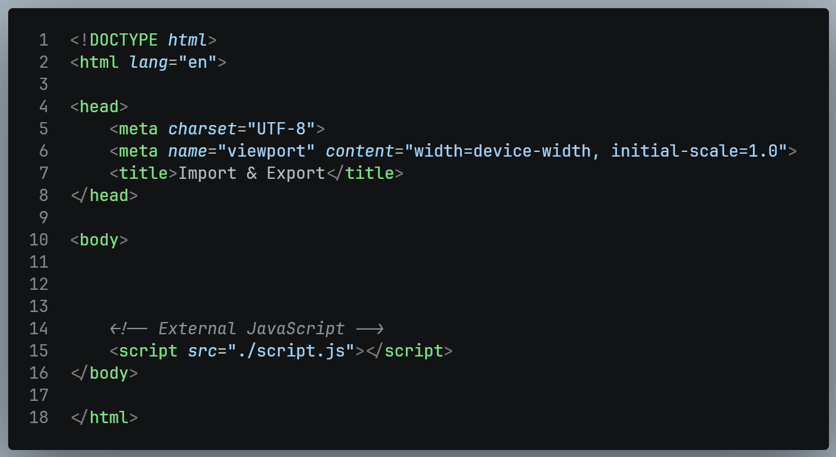
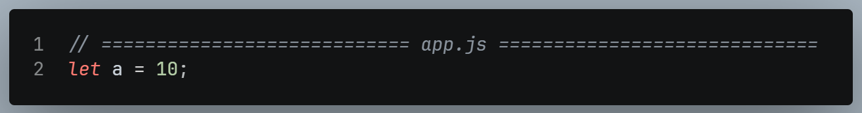
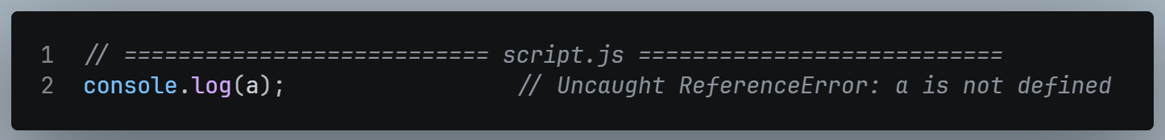
- Solution: Use Import & Export — a mechanism to send data/variables from one file to another.

Prerequisite: Setting File Type to “module”
- To use import/export, your <script> tag must have its type set to module:
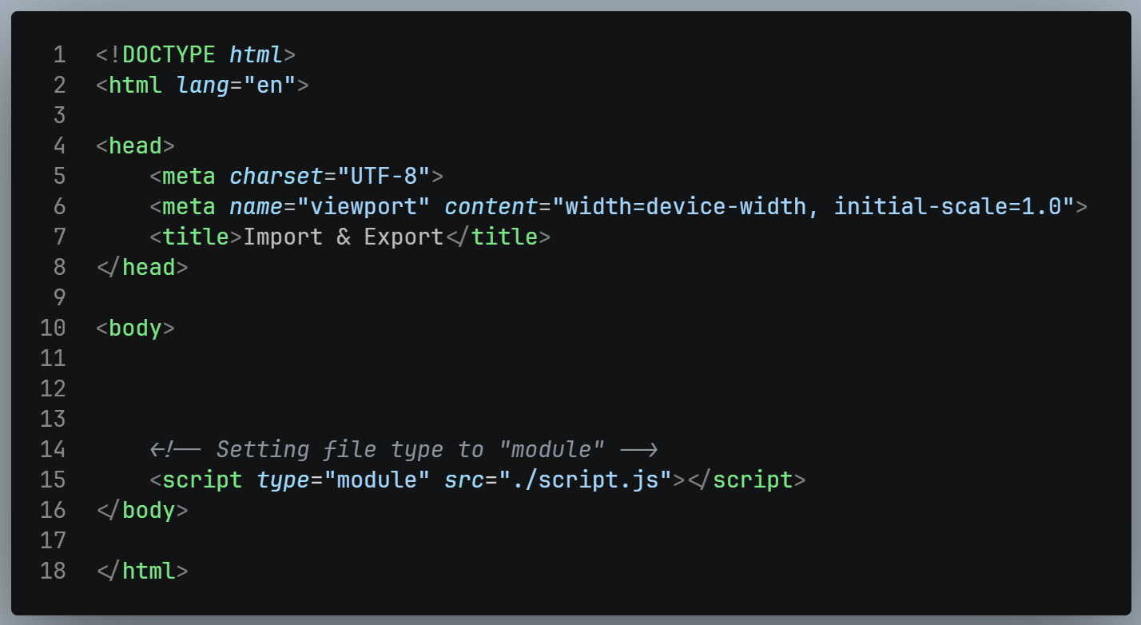
- Benefits of using type="module":
  - Enables import/export syntax
  - Automatically applies strict mode
  - Several other advantages (discussed later in the course)
- This concept belongs to ES6 (ES2015) JavaScript features.

Two types of Export
There are two kinds of exports in JavaScript:
- Named Export
- Default Export

Default Export
- A file can have only ONE default export — it represents the "main" thing a file is sending out.
- Syntax (export):
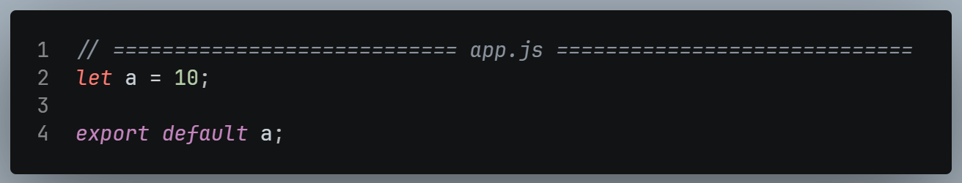

- Syntax (import):
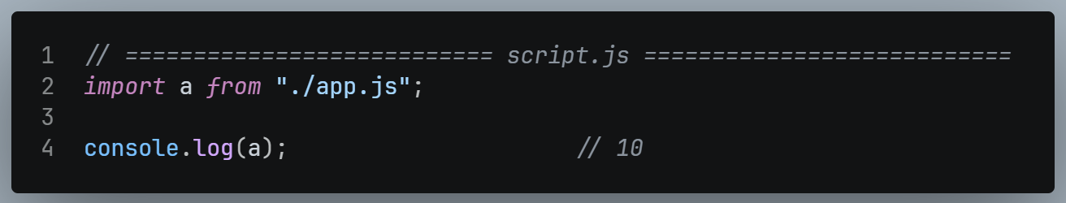

- Key rule: When importing a default export, you can give it any name we like — it doesn't have to match the original variable name.

Example with array:
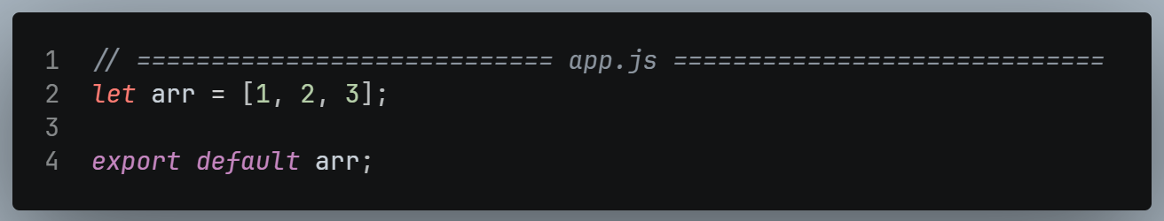
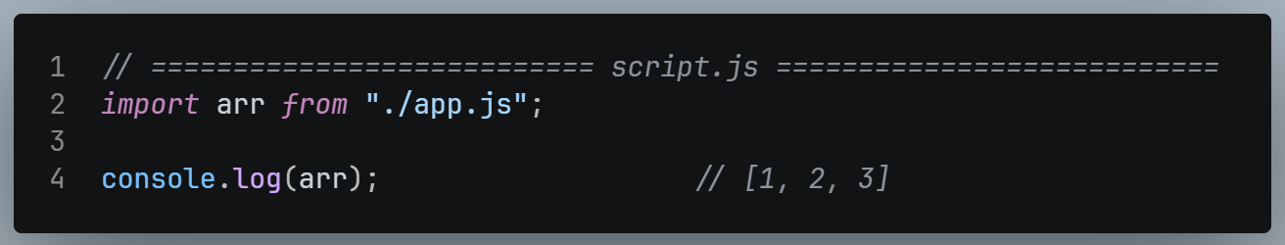

Named Export
- Unlike default export, a file can have multiple named exports.
- Syntax (export): Just add export before the declaration.
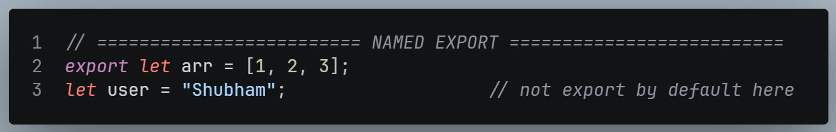
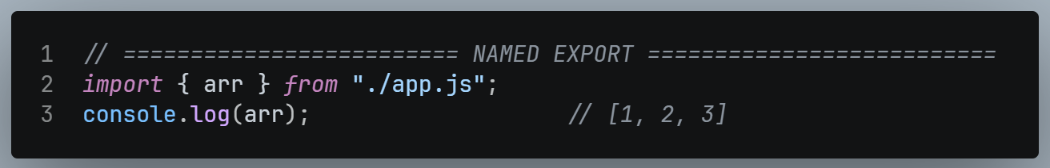

- ⚠️ Important: With named exports, the imported name must match exactly what was exported. Importing with the wrong name will not work.

Combining Default + Named Export (same file)
- A single file can have both one default export and multiple named exports at the same time.
- Example:
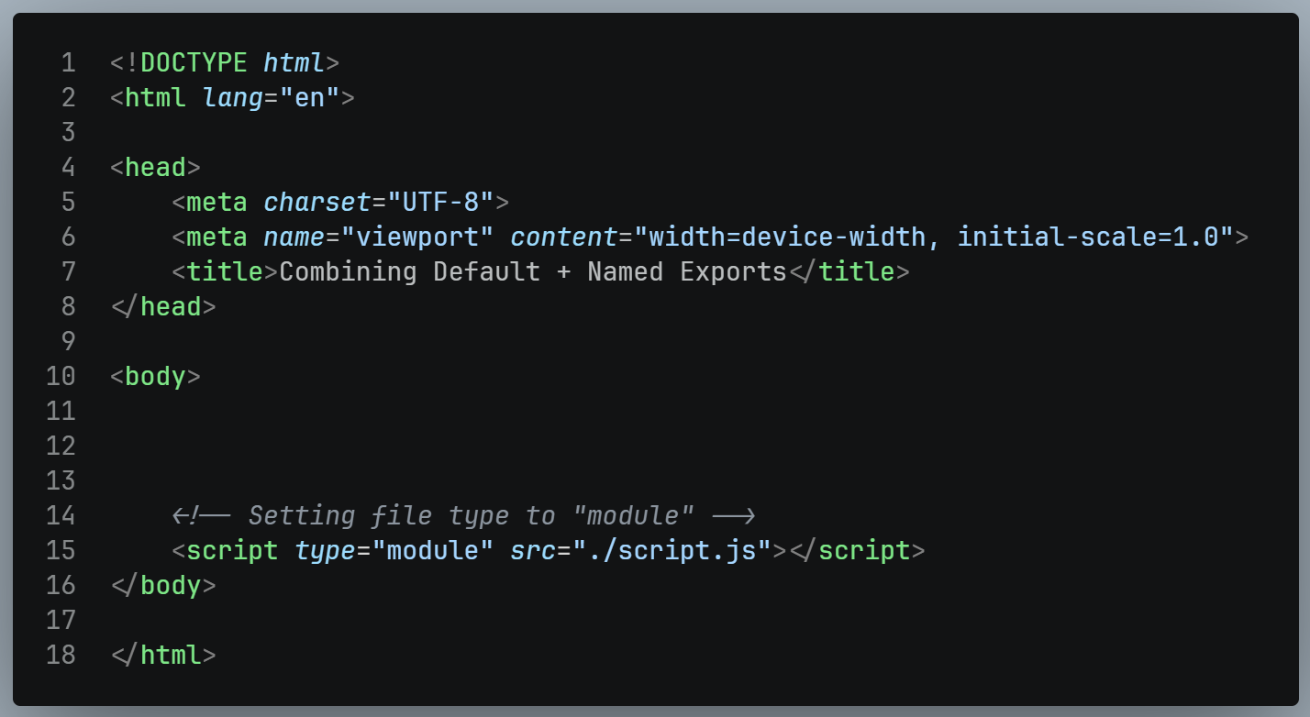
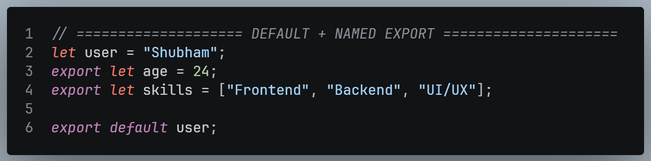
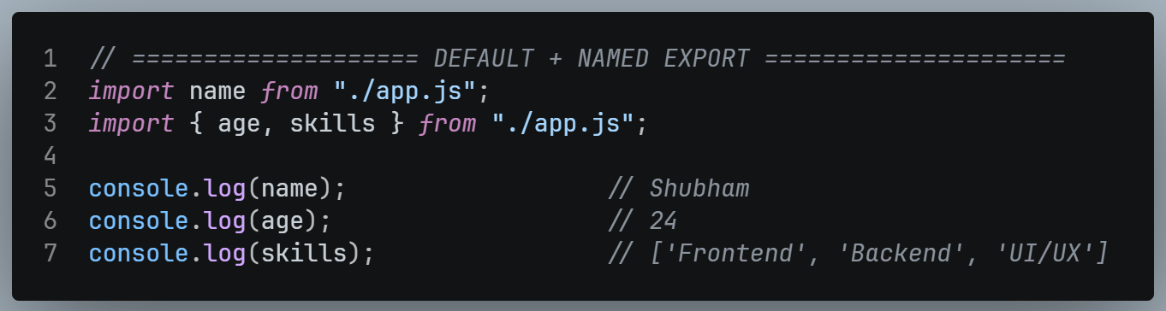

Import from Multiple Files
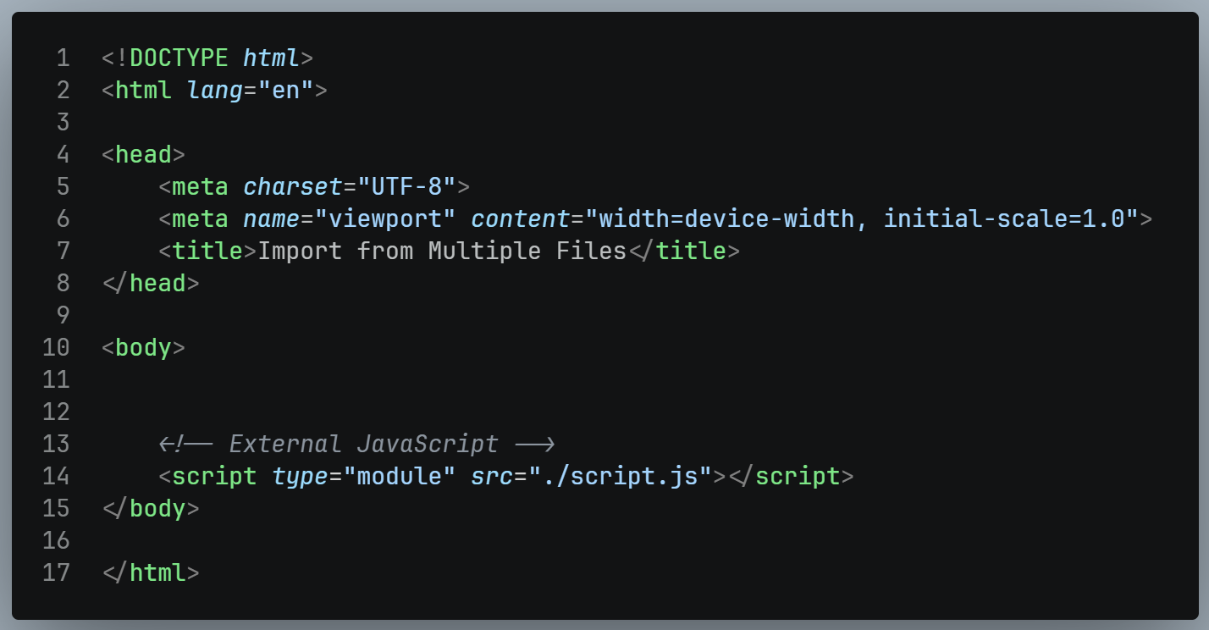
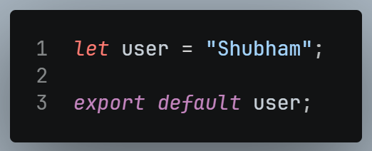
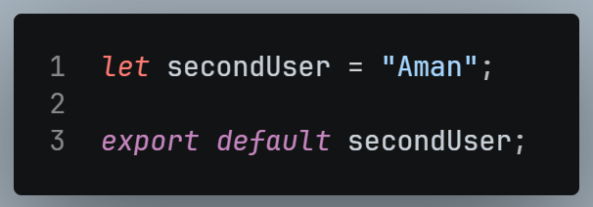
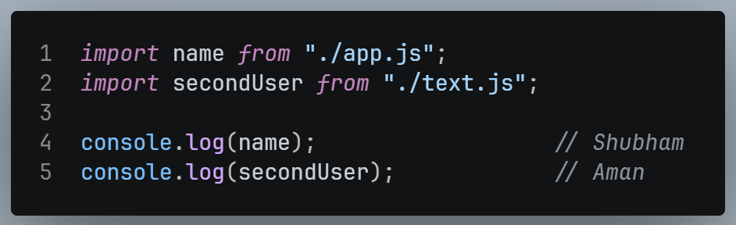

Key Takeaways
Concept | Default Export | Named Export
Count per file | Only 1 | Multiple allowed.
Import Syntax | No curly braces:  import anyName from “./file.js” | Curly braces required:  import { exactName } from “./file.js”
Renaming on import | Allowed (any name works) | Must match the exported name exactly.
Can coexist in same file ? | Yes, one default export can exist alongside multiple named exports.

- This import/export system is fundamental for modular JavaScript (ES6) and is a core concept needed before moving into React, since React apps are built using multiple component files that import/export from one another.

Chapter 3: Real DOM vs Virtual DOM

What is Real DOM?
- Real DOM = the actual DOM — the tree-like structure created when you build an HTML page.
- Structure example:
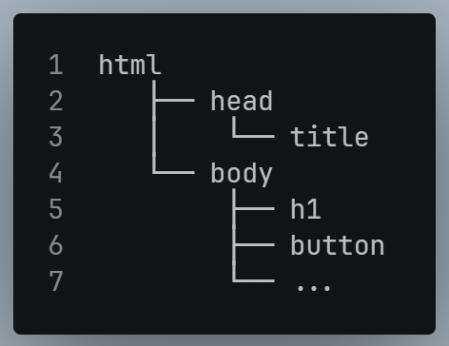
- This is the standard structure browsers use to render a webpage.

The Problem with Real DOM
- When using plain HTML, CSS, and JavaScript, any UI update causes issues because the entire DOM re-renders/reloads, even for a tiny change.
- Example: Suppose an <h1> says "This is my website" and on a button click, you want to change it to "This is my web page."
  - With Real DOM, making this single text change forces the whole DOM to re-render — which is inefficient.
- Analogy given: Imagine a register (notebook) with 1000 entries (names, phone numbers, addresses). If just one digit in one phone number is wrong, you shouldn't have to rewrite the entire register just to fix that one digit — but that's essentially what Real DOM forces you to do.
- This was the exact problem Facebook faced earlier (as discussed in Chapter 2) — even a small notification count update required a full page reload.

What is Virtual DOM ?
- React solved this problem by introducing the Virtual DOM.
- Virtual DOM = a copy (or copies) of the Real DOM, maintained in memory.
  - Technically, React creates one copy, but depending on the code, it may create 2–3 copies.
- How it works:
  - When a change happens (e.g., button click to update <h1>), React updates the Virtual DOM first.
  - React then compares the Virtual DOM with the Real DOM (this comparison process is called "diffing", though the term itself wasn't explicitly used in the transcript).
  - Only the specific parts that changed are updated in the Real DOM — the rest remains untouched.

Benefits of Virtual DOM
- Avoids unnecessary re-rendering of the entire page.
- Only the exact changed element (e.g., just the <h1> or just an image) gets updated.
- Real-world examples:
  - YouTube: After searching and navigating between videos, the search bar text remains unchanged/intact — only the relevant section updates.
  - Instagram: If you have a notification showing "4 new chat messages" and a 5th message arrives, only that notification section updates — not the entire web page.
- Result:
  - Less work for the browser and system.
  - The app becomes significantly faster.
- This is the core concept and purpose of the Virtual DOM.

Introduction to JSX
- JSX = JavaScript XML
- Definition: JSX is basically a combination of HTML and JavaScript — it allows you to write HTML-like syntax directly inside JavaScript.
Why JSX is Useful (Comparison):
Without JSX (Plain JavaScript):
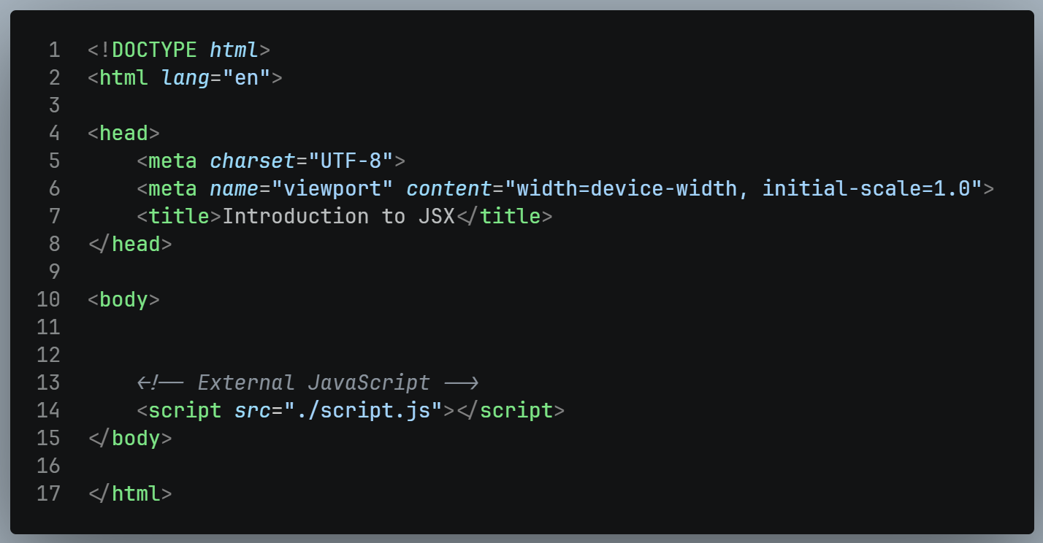
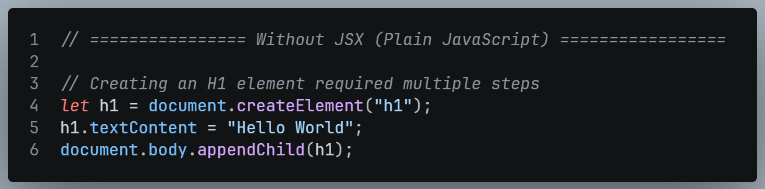
This requires several steps: create element → assign content → append to DOM.

With JSX (inside a .jsx file):
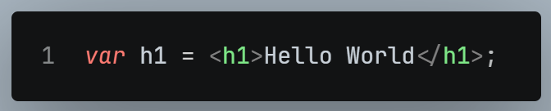
Just one line — much simpler and less effort compared to plain JS DOM manipulation.

Calling Function in JSX
- Functions can be written and called in JSX just like in regular JavaScript, but JSX also allows an HTML-tag-like calling syntax.
- Example:
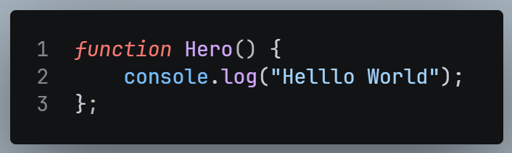

- This function can be called in two ways in JSX:
  - Normal JS way:
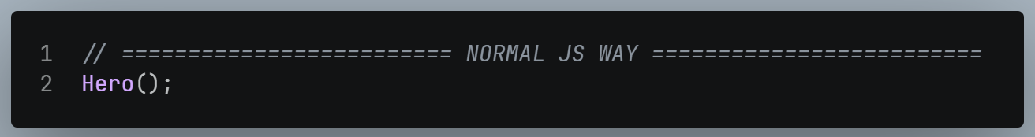
  - JSX / Component – style way:
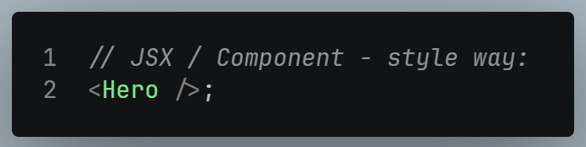

- Both approaches work fine in JSX — this component-style calling convention becomes important later, since React components are typically named with a capital first letter (PascalCase) and called using this tag-like syntax.

Chapter 4 – Setting Up React with Vite

What is Vite (Bundler) ?
- To create a React project, we use a bundler called Vite.
- Bundler: Basically, a tool that helps in creating project folders (with all necessary structure, files, and configurations already set up).
- Why use a bundler instead of building the structure manually?
  - Manually setting up the entire React folder structure requires a lot of repetitive effort.
  - A bundler automates this and saves time.

Vite vs Create React App (CRA)
- Earlier, developers used a command called npm create-react-app to set up React projects.
- This is now deprecated — Reacts own developers have discouraged its use.
- Reason: Reacts team now recommends using React as a library, paired with a framework of your choice (like Next.js or Remix) rather than a rigid standalone setup.
  - Since React is a library (not a framework), it has limited built-in power/architecture compared to frameworks, which provide a full architecture.
- For learning purposes (at this stage), the course uses Vite to simply create a plain React folder (not paired with Next.js etc., which will be covered later).

Creating a React Project with Vite – Step–by–Step
STEP 1: Run the command:
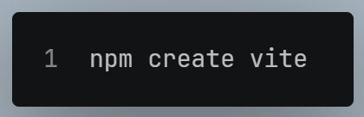
STEP 2: It will prompt for:
- Project name → (e.g., 01_folder — you can name it anything)
- Framework selection → choose React (options include Vanilla, Vue, React, Preact, Svelte, Solid, Qwik)
- Variant → choose JavaScript (other options like TypeScript, SWC exist but will be covered later)
STEP 3: Once done, the folder gets created with a base structure (src, public, etc.), but it cannot run yet because node_modules isn't installed.
STEP 4: Navigate into the folder:
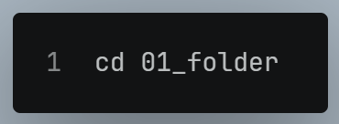
STEP 5: Install dependencies:
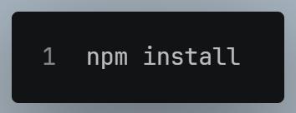
- This installs node_modules, a package needed to run the local server.

STEP 6: Start the development server:
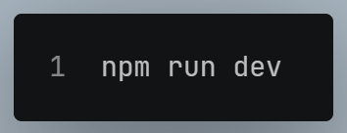
- This starts a local server (e.g., at localhost:5173) and you'll see the default Vite + React starter page.

Note: If Node.js isn't installed on your system, download and install it first (via the official Node.js installer/MSI) — otherwise these commands won't work.

Folder Structure Overview (What Vite Generates)

Folder / Files | Purpose
node_modules | Contains all installed packages, helps run the server.
src | Main working directory – contains App.jsx, main.jsx, index.css, assets, etc.
public | Stores static assets like fonts, images, videos.
assets (inside src) | Stores frequently used items like SVGs, icons, images used within components
index.html | The base HTML file with a <div id="root"> — the mount point for the React app
App.jsx | Root component of the app
main.jsx | Entry point — renders App into the root div.
App.css | CSS file for App component (not used by default in starter; can be imported/used or deleted).
package.json | Contains project configuration — dependencies (e.g., react, react-dom), devDependencies, and version info.
vite.config.js | Vite's configuration file (relevant later, e.g., when using Tailwind).
.eslintrc / eslint config | Linting rules configuration (explained below).
.gitignore | Specifies files/folders to exclude from Git uploads

Understanding App.jsx and main.jsx
App.jsx (Basic Functional Component):
- Typing rafce (a snippet shortcut) generates a basic functional component structure automatically.
- Example demonstrated:
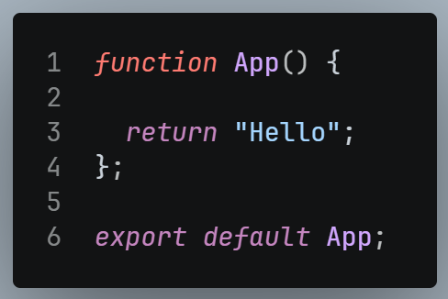

- Without export default App, nothing will show on the page (blank/white screen) — because the component isn't being sent anywhere to be used.
- Since this is JSX, you can directly return HTML elements too:
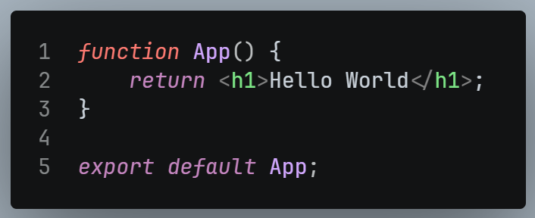

main.jsx (Entry Point / Parent of App.jsx)
- App.jsx "parent" is main.jsx — meaning main.jsx imports and renders App.
- Key operations inside main.jsx:
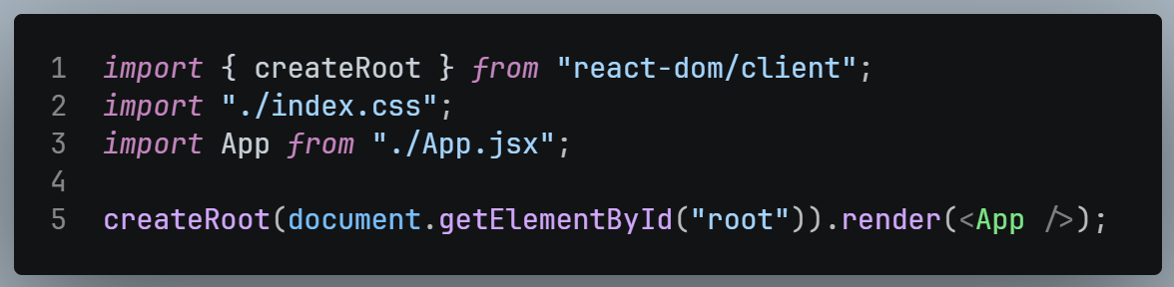

- Explanation:
  - createRoot() creates a root — this is the Virtual DOM root concept discussed earlier.
  - It selects the HTML element with id="root" (found in index.html) as the mount point.
  - render() renders the App component (function) inside that root div.
- <App /> can also be written as App() — both work since it's just a function call; JSX-style (<App />) is more conventional.
- React.StrictMode (default wrapper in main.jsx) was removed/mentioned as not relevant at this early stage.

The Rendering Chain (Hierarchy)
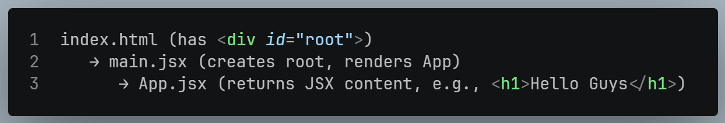

- Whatever is returned from App.jsx gets inserted inside the <div id="root"> in the final HTML — verifiable via browser Inspect Element.

CSS in the Project
- index.css is imported in main.jsx — this is the CSS actually applied globally.
- App.css is not used by default in the starter template but can be imported into App.jsx if needed (CSS usage with components will be taught later).

ESLint – Why it’s Needed
- ESLint helps enforce custom coding rules across a development team.
- Problem it solves (Collaborative Coding):
  - When multiple developers work together (e.g., a Product Lead + Junior Developers), everyone may have different coding habits:
    - Some use semicolons, others don't (optional in JS).
    - Some use single quotes, others double quotes, others backticks/template literals — all functionally equivalent for strings.
  - These small inconsistencies cause merge conflicts when code from different developers is combined.
- Solution: ESLint lets teams define a set of shared rules that everyone must follow, reducing inconsistencies and merge conflicts.
- Example rule already present by default: Warns if something is declared but never used (e.g., "React is declared but its value is never read") — encouraging developers to only import what they actually use.

.gitignore – Why it’s needed
- Used to specify files that should NOT be uploaded to GitHub, even though they're needed locally.
- Common exclusions:
  - node_modules — too large/unnecessary to upload; anyone can reinstall via npm install.
  - VS Code config files — not relevant to others.
    - If .env were uploaded to GitHub, others could access your private project data/API keys — hence it's excluded.
- Anything "not useful to others" or "sensitive" goes into .gitignore so it's excluded from version control uploads.

Uploading the Project to GitHub
Steps Demonstrated:
- Create a new repository on GitHub.com (example name: react-vite), keep it public, no README/no extra files added initially.
- In terminal, navigate to the parent folder (outside the project folder).
- Run Git commands in sequence:
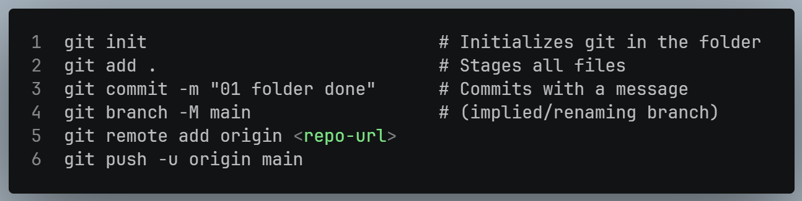
- After pushing, refresh the GitHub repo page — the uploaded folder and source code will now be visible there.

